Bram,
In case anyone is interested I though I would share how I made my strips.
I used a gang cutter (my Ryobi sliding miter table saw to cut 3 strips at a time and a tandem bead and cove mill that I designed myself to add the bead and cove in one pass.
My strip mill can handle different width strips fro 1/2 inch to 1.5 inch but before starting I plane all planks to the same thickness so that my strip mill will work without me having to constantly adjust it. I also joint any planks that have a cup in the 1inch side so that the fence works efficiently. I use a full length out-feed support and tried corn meal as lubricant. I made my own fence feathers from cutting board with a 1/8 inch router bit. I made my own bushes for the gang cutter from many layers of fibreglass and epoxy. These must be perfectly centrifugally balanced. I made them with a hole saw and an arbor sized forstner bit. They are critical if you want to achieve strips that have no blade marks. I used fibreglass packing tape for fine adjustment shims but a slightly dull blade (Freude 7 1/2 diam 40 tooth 1/6 in kerf) and impatience heated the blades and arbor enough to melt the glue a bit allowing a few strips to be a smidge thinner than I wanted. These went into the bulkheads. I suggest fibreglass shims would be better. My milled strips are a bit wider than 3/4 inch and exactly 1/4 inch thick. (JNJ Tools vernier dial calipers) I kept the strips in bookmatched slabs/bundles of 5 or 6 with sticky tape just as they come off the plank.

Fig A Gang cutting strips 3 at a time from 1x6 Figure B Bead Mill
clear cedar decking.

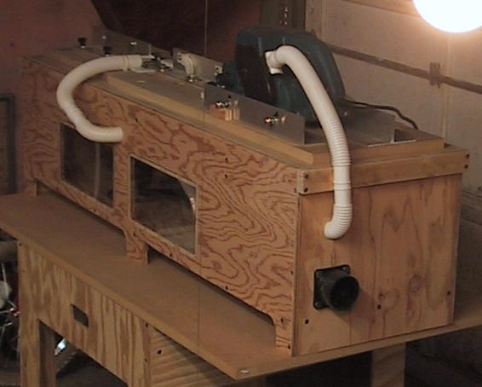

I designed the tandem bead mill with about 8 degrees of freedom to handle different width strips and different depth of bead and cove. The bead cutter makes the first bight and the cove cutter is climb cutting. That is, the router bit is cutting in reverse, in order to get a very fine edge and reduce tear-out if the grain is run-out or wavy. Ball bearings hold the strip horizontally and vertically against the fences. The bearings after the bead cutter head have a concave section to engage the bead and a 1/4 inch section rod engages the cove and guides it out of the cove cutter head and under the power feed so that the cove edges do not get damaged against the fence. It has a power feed that engages when the strip is just through both the bead and cove cutters. It runs at about 20 to 40 feet per minute and is continuously adjustable down to about 10 FPM.
Each router/laminate cutter motor is independently switched and a 15 ft power cord with a single stop/emergency plate switch which controls all power is on the operator side at the in-feed end. A 6.5hp ShopVac provides some dust removal through a manifold inside and the white crimped pipes but more importantly cools the power feed (JNJ Tools 4 inch Belt Sander) who's fans do not work sufficiently at low speeds. The whole things is made from one 4ft length of 1/8 X 2 inch alloy angle one sheet 2ftX 4ft MDF from the Borg and some left over ply wood from the strong back and jig stand sheet and is designed to sit on my table tool stand and match the height of all my surfaces (the same as the table saw). It cost me overall about >=$100US.
I think I could cut all the strips for a boat in one long day or 2 easy days. As it was, I really wished I had a helper to stack as I cut. This could have made it very fast, because I was book-match bundling the strips every 6 strips and shelving them by colour.
Since the temperature outside was below 0F when I cut, I had to open the kitchen door for the length in the garage rather than the garage doors. The 16 footers were a particular problem and I had to open the fridge door and move the groceries aside to get that extra foot of space I needed. Lots of fun! Does anyone else have a spouse who KNOWS they are absolutely crazy?

Here they are in use (Figure 3), with the glue not dry yet on the footballs.
I used the strips with any kind of imperfection or minor defect for the undersides, worst side inside About 46 across the bottom.

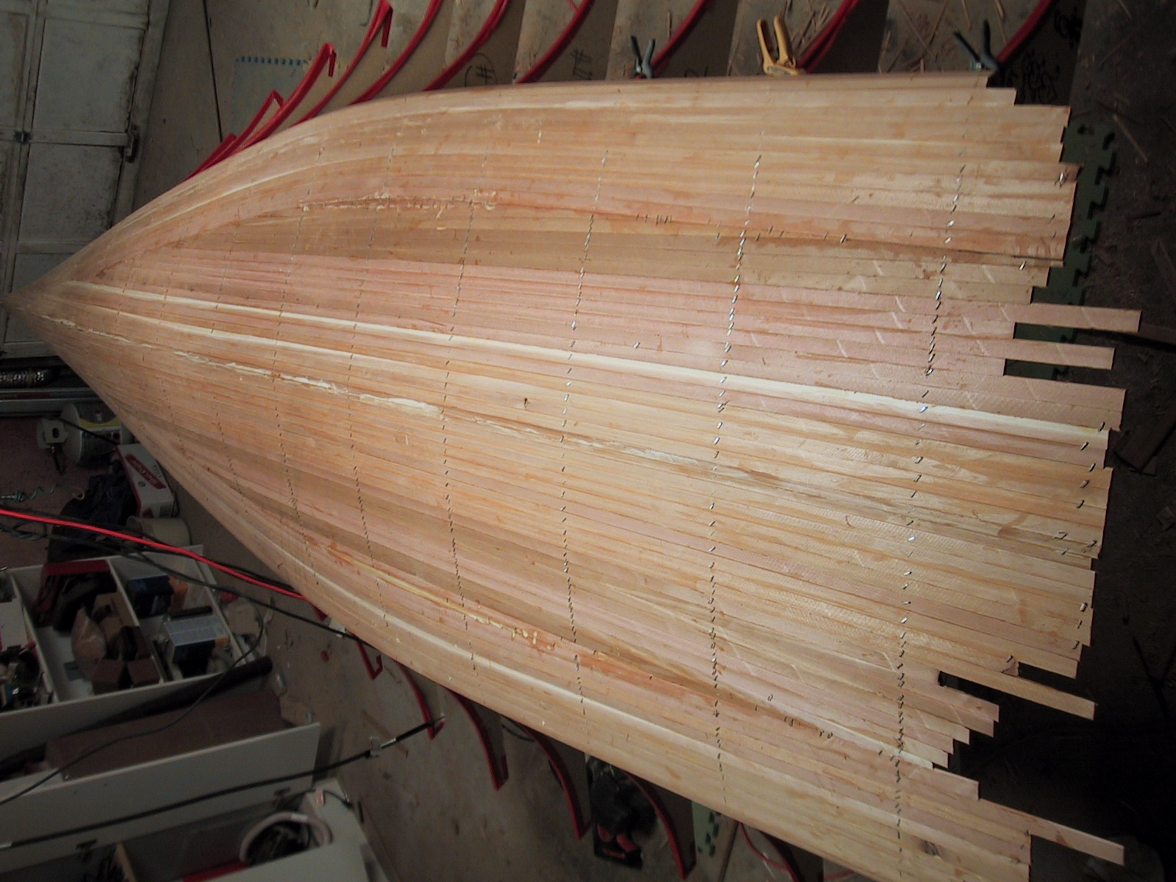

More later on
- Avoiding making the topside and deck strips look $#/%%)( like perforated toilet paper at each section position or “Uncle Bram, what are all those little holes in your boat, and how come my dads boat doesn’t have any?…”
- Foam blanks for easy fabrication of toe-rails ex post facto hull -- and other select parts

Greg (I’m going to catch up) Ryan
Swift Solo -- Rose
USA 009

BTW did you hear about the aerospace engineer who designed a row of small strengthening holes in the wing roots of a new jet fighter... based on the S#/%house principle. You know, paper never tears on the perforated line. But BTST my scientific observation is… that it always tears on the dotted line when wet! So watch out swifties.
G

